
Installation and Repair of Telecommunications Equipment
[Type here]
Module 21 Telephone network systems installation

VOIP lab experiment#1 Configuring the virtual box

Installation and Repair of Telecommunications Equipment

Name of student:
Group Number:
Date:

Installation and Repair of Telecommunications Equipment
[Type here]
Module 21 Telephone network systems installation

The purpose of the lab is to demonstrate the ability of the students to configure the virtual box.

Oracle VM VirtualBox is cross-platform virtualization software. It allows users to extend their existing computer to run multiple operating systems including Microsoft Windows, Mac OS X, Linux, and Oracle Solaris, at the same time.

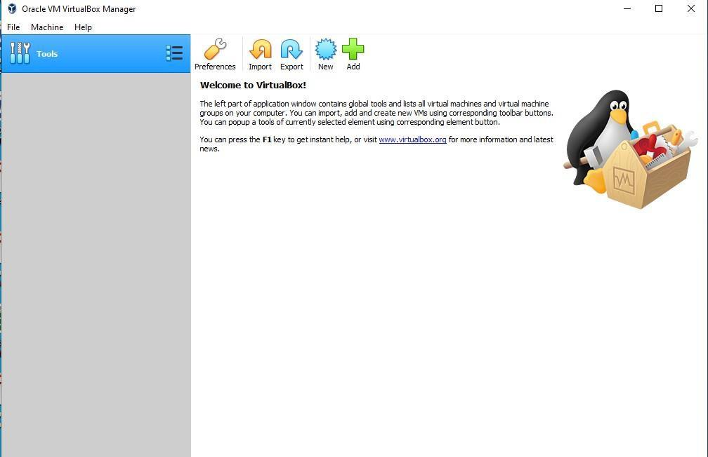
- Open Virtual box software on your desktop

Installation and Repair of Telecommunications Equipment
[Type here]
Module 21 Telephone network systems installation

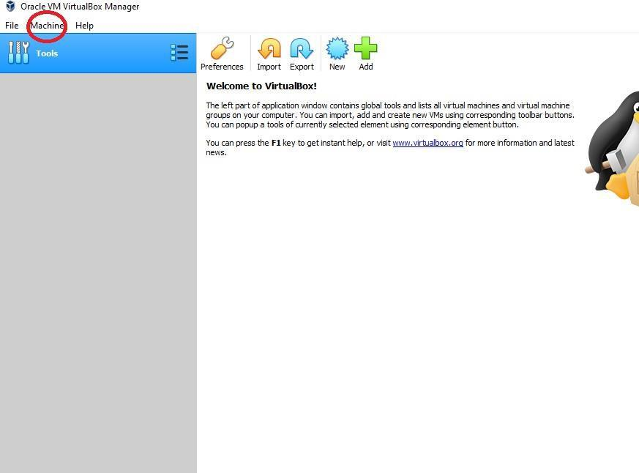
- Click on “machine”, and choose “new”

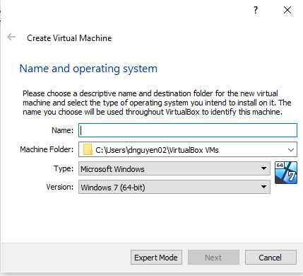
A window like this will appear.

- Setup the following:

  - Name: Elastix
  - Type: Linux
  - Version: RED Hat 32-bit
  - Press Next

Installation and Repair of Telecommunications Equipment
[Type here]
Module 21 Telephone network systems installation

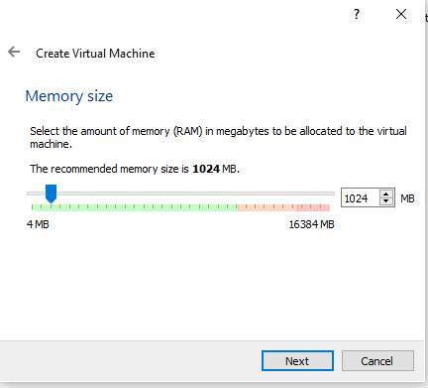
- For memory size, choose 1024MB. Click next

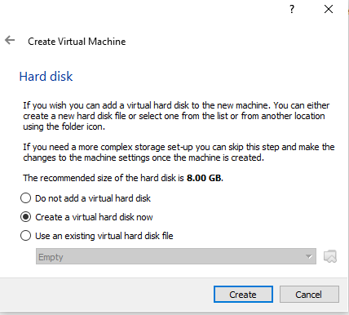
- Choose create a virtual hard disk now and then click create

- Choose VDI (virtual box disk image), and then click next

Installation and Repair of Telecommunications Equipment
[Type here]
Module 21 Telephone network systems installation

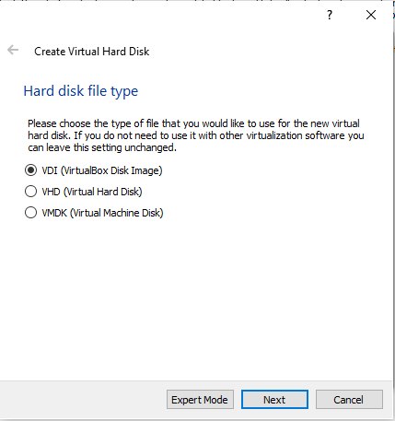
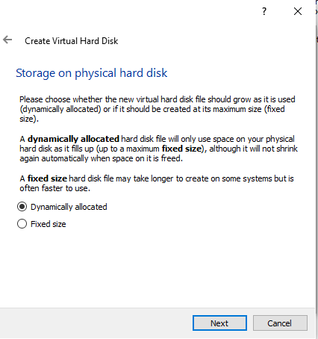
- CHoose “dynamically allocated”. Then click next

- You want to create a hard disk of 8GB, so click on create.

Installation and Repair of Telecommunications Equipment
[Type here]
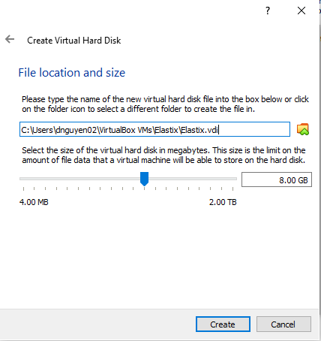
Module 21 Telephone network systems installation

Installation and Repair of Telecommunications Equipment
[Type here]
Module 21 Telephone network systems installation

Once all the previous steps are completed, you can now access to the main page of the virtual box and configure. You will be configuring 2 different settings:
- Network
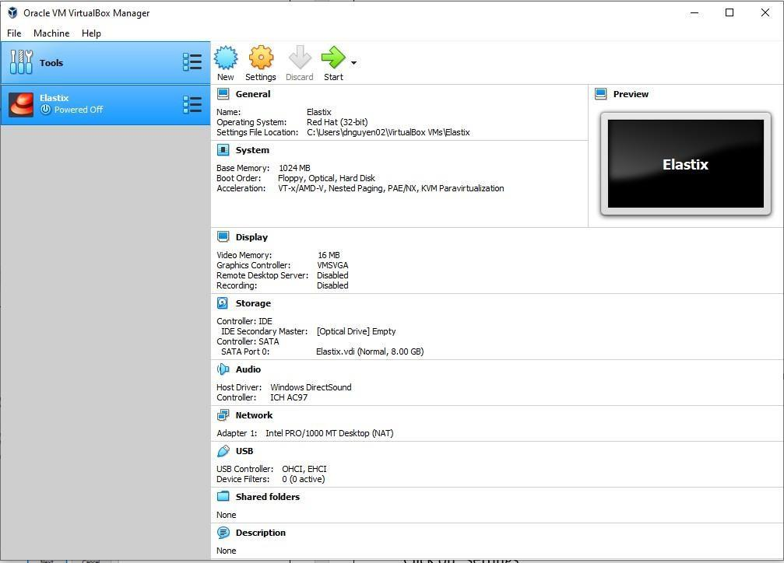
- Storage

Click on settings to choose the configuration that you want to modify.

Installation and Repair of Telecommunications Equipment
[Type here]
Module 21 Telephone network systems installation

Network Settings
In this setting, you will be prompt to set the attached to and the name of the adapter:
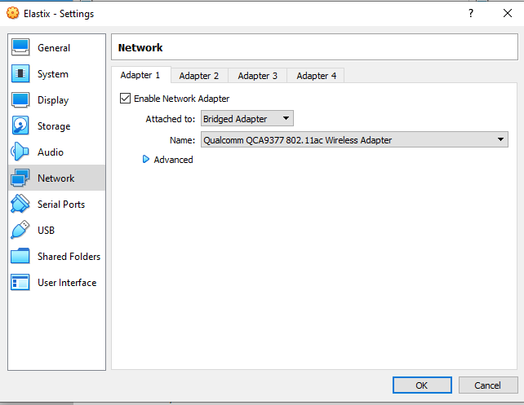
Attached to: Bridge Adapter
Name: Wireless Adapter

Click on ok once this setup is completed.
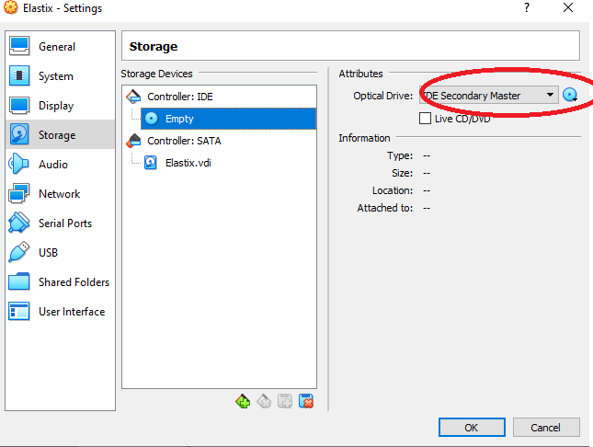

Installation and Repair of Telecommunications Equipment
[Type here]
Module 21 Telephone network systems installation

Storage setup
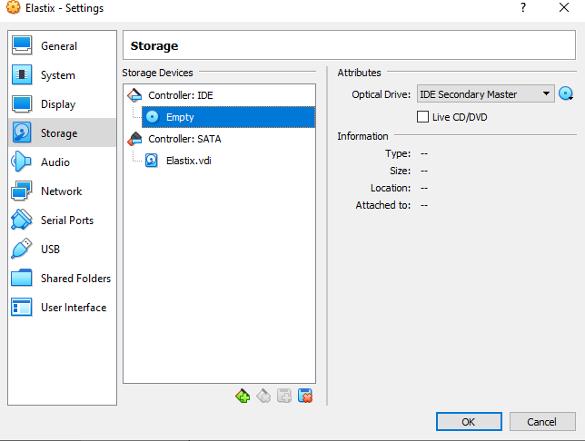
In controller: IDE, click on empty

Installation and Repair of Telecommunications Equipment
[Type here]
Module 21 Telephone network systems installation

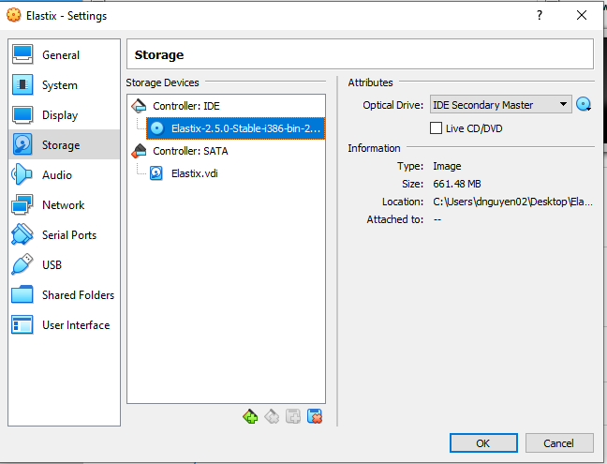
Browse and attached your FreePBX iso file

Click on ok to go back in the main window and start the virtual Box simulation

Installation and Repair of Telecommunications Equipment
[Type here]
Module 21 Telephone network systems installation

A screen like this should appear once you start the virtual box machine.

